**Brotomotiv Car Wash..**

### The Brotomotiv Car Wash project aims to revolutionize the car washing experience by providing a

state-of-the-art, environmentally friendly, and customer-centric facility. Through innovative technology and a focus on efﬁciency, the project will offer a range of tailored wash packages to meet the diverse needs of car owners.

**By Yogesh Lakde.**

# **Abstract..**.

The Brotomotiv Car Wash Automation System aims to revolutionise the car washing process by integrating advanced technology for a more efﬁcient,

eco-friendly, and user-friendly

experience. This project will develop an automated car wash system that uses minimal water, eco-friendly detergents, and advanced sensors to provide a thorough cleaning service. The system will include features such as sign up and login pages, types of washes, online booking, contactless payment, and

real-time updates to enhance customer

convenience and satisfaction.

# **Introduction...**

The Brotomotiv Car Wash project is an innovative initiative aimed at transforming the traditional car wash industry. By combining cutting-edge technology, environmentally conscious practices, and a commitment to customer satisfaction, the project seeks to redeﬁne the car washing experience.The Brotomotiv Car Wash Automation System addresses these issues by implementing cutting-edge technology to automate the car wash process, reduce water consumption, and use biodegradable cleaning agents.This project aims to provide a seamless and eco-friendly car wash experience that meets the needs of modern consumers.

**Literature Survey...**

##### 1].Review Paper on Automatic Car Washing System:-

**Author:-Miss Sonali Gaonkar.**

UG Student Department of Automobile Engineering Saraswati College of Engineering, Kharghar, Navi-mumbai,

**Abstract:**- The Automatic car wash is designed to wash sedan type of cars available in Indian Market. Ranging for as small as Honda Amaze (3.9m) to as long as Mercedes S550 MayBach (5.45m).The number of cars are increasing on Indian roads exponentially, as the purchasing power of people are increasing. Hence there is a need of High end Technology that fast, quick & efﬁcient. People

nowadays are more concern about the looks of car & a car lover won’t like his car dirty. So this project would be smart solution to the problem.It also has to be eco-friendly & should not harm our environment. As a dirt on car can cause many problems ranging from spoiling of paint job to even causing hindrance in working of suspensions.

###### 2]. Intelligent Automatic Car Washing System with Sensor Triggered Conveyor Belt:-

**Author:- PRAVEEN KUMAR REDDY**,

Assistant Professor, Guru Nanak Dev Engineering College, Bidar.

**Abstract**- An individual customized vehicle wash is given which consolidates an isolate region to the vehicle. A versatile ﬂuid regulating gathering is mounted on a track in the separated territory with the objective that ﬂuids can be directed to the surfaces of a stationary vehicle orchestrated inside the separated region. The ﬂuid directing social affair is driven by a drive motor longitudinally back and forth about the vehicle while ﬂuids are

managed to the vehicle. Under PC control, the ﬂuid allocating get together progressively sprinkles a warmed chemical/water mix under modestly low strain and a short time later warmed ﬂush water constrained to clean the vehicle. A steam-shower as is atmosphere along these lines given which updates the ejection of earth .

###### 3]. Smart Car Washing Center using IoT Based:-

**Author:- Prof. M. N. Kadam**

Department of Electronic & Telecommunication Engineering ,SVPM’S COE Malegaon (BK) Baramati, Maharashtra, India.

**Abstract:**- This Paper present work on Automatic car washing using an IOT based paper. At mega328 programmable logical controller which is a type of microcontroller. The automatic car washing using conveyer belt system is already in available market. In our project we are using pressure cylinder to lift the car. Our project is prototype in which a car enters a washing station and automatically gets

clean up. We are using various motors in this project such as dc motor, water motor and motor driver. This entire component is controlled using microcontroller. The main aim of our project is use less water, more efﬁcient washing. Internet of Things (IoT) is overturning traditional Business models.

Proposed System (System Architecture)..

The proposed Brotomotiv Car Wash Automation System consists of the following components:

1].Sign Up Page...

Personal Information :-

Customers can enter their name, email, and contact details to create a secure account.

Contact Details:-

Customers have to enter their Personal Phone Number for creating a Account.

Password:-

Customers will have to create a password to be able to have a Successful login.

# 2].Login Page..

## Username:-

Customers can enter their registered username to access their Brotomotiv account.

## Password:

#### Customers can securely enter their password to authenticate their identity.

3].Types of Washes…

##### i].Basic Wash:-

Exterior cleaning, wheel and tire cleaning, and a basic drying service.

ii]. Premium Wash: Comprehensive exterior cleaning, tire dressing, and interior vacuuming.

##### iii].Deluxe Wash:-

Full exterior and interior cleaning, including hand-dried ﬁnishing and application of protective coatings.

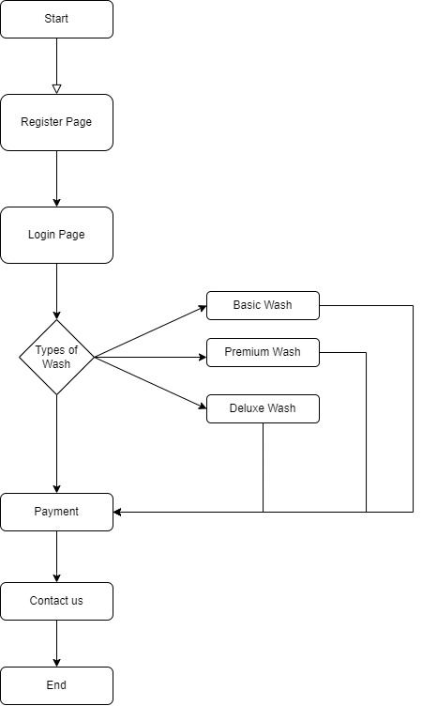

# **Conclusion...**

The Brotomotiv Car Wash Automation System aims to set a new standard in the car washing industry by combining efﬁciency, convenience, and environmental sustainability. By leveraging advanced technology, this project will provide a superior car wash experience that meets the demands of modern consumers while addressing environmental concerns. The successful implementation of this system has the potential to transform the car wash industry and contribute to a more sustainable future.

# **References...**

#### 1]. Review Paper on Automatic Car Washing System. By:-Miss Sonali Gaonkar.

2]. Google.

#### 3]. Smart Car Washing Center using IoT Based. By:-Prof. M. N. Kadam.